A CRUD MERN app

1. Followed blog [How to Build REACT MERN Stack Todo CRUD Application - RemoteStack](https://remotestack.io/how-to-build-react-mern-stack-todo-crud-application/) on creating a
   1. React App
   2. REST API using node.js as the express server
2. Install mongodb locally. This was for a windows user. Took defaults

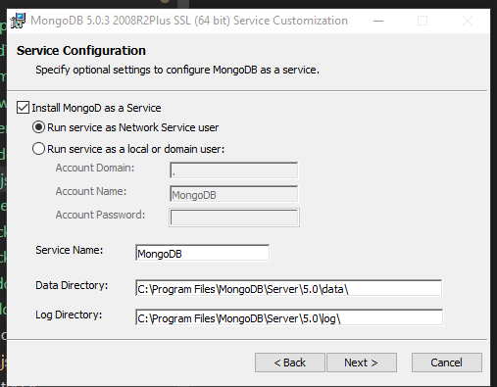

1. Set up steps for mongodb using <https://medium.com/@LondonAppBrewery/how-to-download-install-mongodb-on-windows-4ee4b3493514#:~:text=MongoDB%20Install%20on%20Windows%201%20%E2%80%94%20Download%20the,need%20to%20set%20up%20MongoDB%20on...%20See%20More>.

Node.js backend

* Allows you to write the backend code in js too
* Babel – transpiler to write es6 syntax & still

React Classes vs Hooks

* 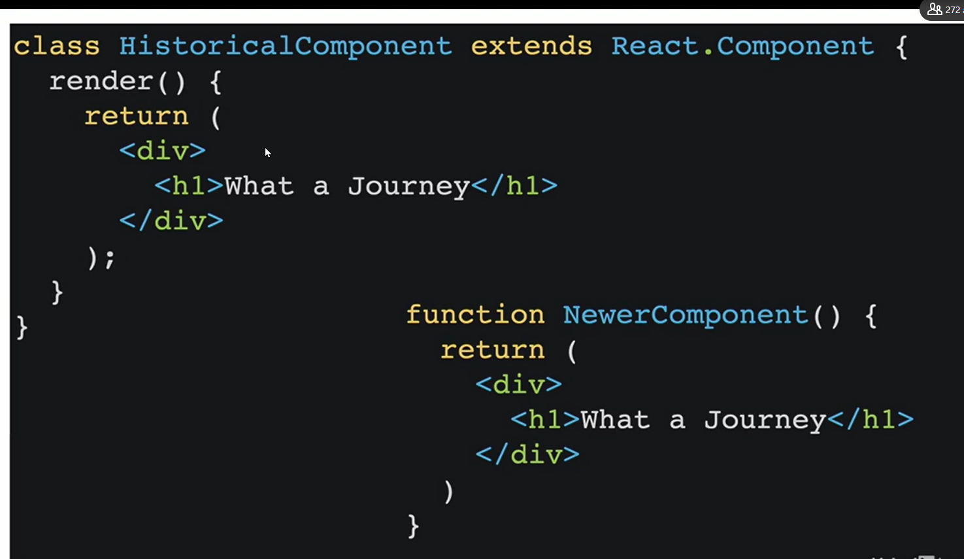
  + Hooks allows:
    - Add status to function components
    - Abstract logic it separate functions
  + 